

Assessments of Raster-to-Vector (SVG) Conversion software and 3D Printers for Tactile Graphics
By Brian Mac Donald, National Braille Press, and Robert Hertig, Engineer-Northeastern University

Executive Summary:
The National Braille Press (NBP) subcontract is to research and assess SVG conversion software (from bitmap or raster images to SVG) to determine what is best overall choice for DIAGRAM’s future partners (content providers, publishers, authors, teachers and students).
The goal is to identify a version that is affordable, and easy to use for publishers and individual content providers, so that they can incorporate SVGs in materials at the beginning of the production cycle. Similarly, this tool could be used for downstream accessibility providers to convert images to an SVG, and through simple software conversions, one can manipulate these images for tactile graphic renderings.
Once a good conversion tool is identified, it will be easier for DIAGRAM to reach out and engage content providers to consider incorporating SVGs at the beginning of the production cycle, through the development of a process that is logical, is free or affordable, and is easy to implement.
After filtering through much SVG software, we selected five SVG conversion programs that were compared based on ease-of-use, cost, editing features, and quality of SVG output, by converting two images representing different types of textbook diagrams.
A second component of the subcontract is to provide an update on the potential use of 3D printers in the production of tactile graphics .Currently there is an explosion in the popularity of 3D printers, for schools and hobbyists, and this tool has the potential to be used for the development of tactile graphics for tests and textbooks. National Braille Press is researching the quality, speed and various materials that can be used effectively. Preliminary results indicate that 3D printing could be a viable solution that will save labor and production time.

Introduction to SVG
Scalable Vector Graphics (SVG) specification is an open standard, XML based markup language for describing two-dimensional images and graphics applications. It has been under development by the W3C since it was first introduced in February, 1999. Currently the W3C has recommended SVG 1.1. Some minor changes are being incorporated into version 1.2 now but it has not been released, and SVG 2.0 is under development.
For publishers, including SVGs in a book at the very beginning of the production cycle provides benefits in both quality and file size for the eBook. Raster images (bitmap, PNG, JPEG, GIF) are a series of unconnected pixels, and when a customer zooms in on a raster image it gets blurry or “pixelated”. A vector graphic renders sections of the image as discrete objects allowing for interactivity, so when you zoom in on that graphic the resolution remains sharp. From an accessibility perspective, being able to zoom in on text and graphics without loss of quality, can be very helpful for people with visual impairments and eye conditions.
Vector graphics also have the advantage of having a smaller file size compared to a raster image. For photos a raster image is still better, however for text, line art, drawings, charts, graphs, and maps, vector graphics are the best choice.
SVG images can be created and edited with a number of text editors, but it is often more convenient to create them with drawing programs such as Inkscape.
Raster-to-vector conversions are a process that converts a bitmap file to a SVG file, which can be scaled to any size without loss of image quality. Two different types of SVG conversions are considered here: full image vectorizing and outline tracing.
Full image vectorization: This creates an SVG file with multiple paths and allows for translation of grayscale or color images from raster to vector. This is useful when trying to preserve as much as the original image as possible. Full image vectorization is the desired outcome we want for publishers to utilize as they develop their images, diagrams or graphics in the production cycle.
Outline tracing: This creates a single path that creates an outline of a black and white image. This is useful and important to allow manipulation of the image for tactile graphics, including 3D modeling programs. It could be used by publishers in some context where they wanted to identify or alter a raster image for a specific clarification.

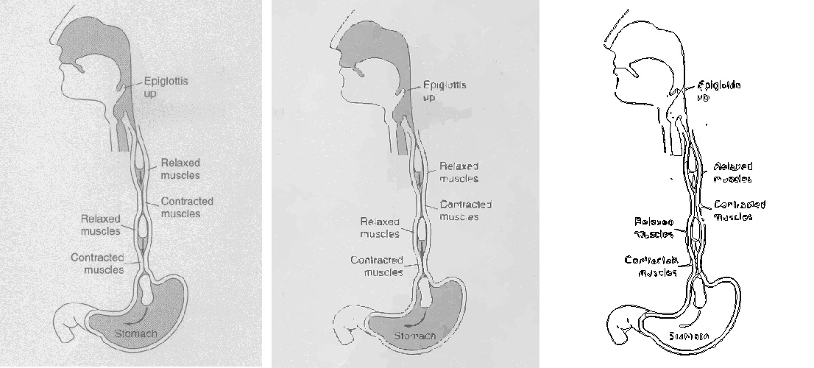
From left to right: Original image, full image vectorization and outline trace. In this example, both vectorizations were done using Autovector. Note that a higher quality initial scan from the original image will yield better output results.

SVG Tool Descriptions
The SVG conversion programs tested here differ greatly in their usability, capabilities, output quality and intended use. Of all the SVG conversion programs available, these 5 were chosen as the most effective for their availability, cost, and popularity:
- Autovector: A simple raster-to-vector conversion program. There is limited control on the output of the traced image and more importantly there are no editing features for raster or vectors files. It is capable of creating color and outline vector types. Originally developed to convert photographs to cartoons.
- Inkscape (Potrace): Inkscape itself is a powerful vector editing program that has many tools for editing SVG files. It includes a plug-in called Potrace that handles the conversion of any raster files that are loaded. Potrace provides multiple different tracing methods for both full image vectorizing and image tracing. It also has additional parameters to further fine tune the output.
- Scan2CAD: A powerful raster-to-vector converter that also includes useful tools for processing raster images prior to conversion. These tools allow for speckle removal, edge smoothing, de-skewing and other useful image cleaning operations. Once the image is traced, there are many vector editing tools available to further refine the vector file. Scan2CAD was originally developed to convert architectural blueprints, engineering drawings to SVG files.
- WinTopo: A conversion program originally developed to translate topography maps into digital form. Wintopo features “a one-touch vectorization” button that makes conversion very quick and easy, but makes adjusting parameters more difficult.
- RaveGrid: A basic, yet powerful raster-to-vector application developed by the Los Alamos National Laboratory. It features very easy-to-use automatic image vectorization, but doesn’t work for outline tracing.

Testing & Comparison
Each SVG conversion program was evaluated thoroughly for its ability to translate raster textbook diagrams to vector images. Since there are many different types of diagrams used in textbooks, two dissimilar images were used for testing: a.) a circuit diagram and b.) a biology diagram. For the circuit, the settings in the SVG conversion tool were optimized for outline tracing. For the biology diagram, the settings were optimized for full image vectorization.
If one looks closely at the converted images you will notice inconsistencies in some programs compared to the original JPEGs, specifically in comparing shading, line smoothness, line connectedness, text, corners, and resolution.
Original JPEG  (Fig. 1a,1b) |  | 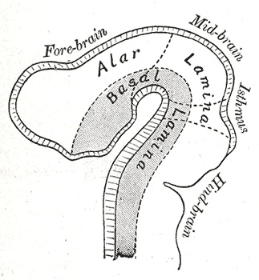
 | Outline Tracing | Full Image Vectorization
Autovector  (Fig. 2a,2b) | 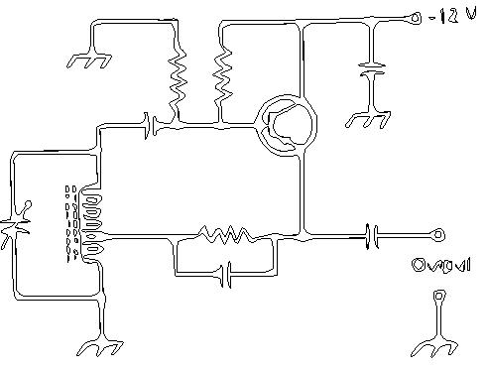 | 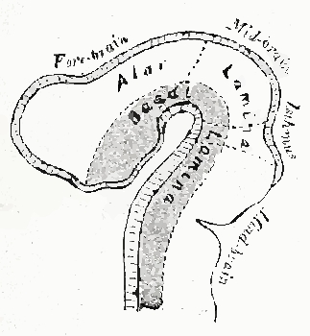
Inkscape (Potrace)
(Fig. 3a,3b)
Scan2CAD | n/a | n/a
Wintopo
(Fig. 4a,4b)
RaveGrid  (Fig. 5a*,5b) |  | 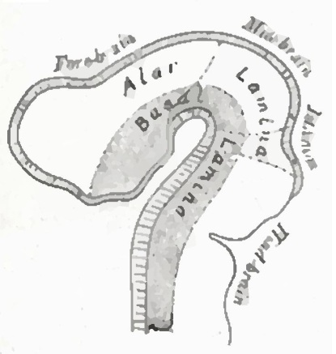
* Figure 5a is actually a second example of full image vectorization, since outline tracing is not available in Ravegrid.

Output Analysis
Autovector: Autovector’s outline tracing ability clearly shows error in the output as shown in fig. 2a. This is undesirable when converting for use in tactile diagram rendering. However, Autovector did create a nice job of performing a full image vectorization on the biology diagram as shown in fig. 2b, however the editing capability is non-existent. Autovector is free to try, $49 for full license.
Inkscape (Potrace): Inkscape’s outline tracing ability is by far the best (shown in fig. 3a). It produces straight, connected paths that have the right amount of smoothness; ideal for converting images for tactile diagram rendering. Inkscape’s full image vectorization ability is also good, however it can result in a slightly blurry output image. Inkscape is completely free under general public license (GPL).
Scan2CAD: Scan2CAD was unable to produce results that would be useful for this application. While it is useful for scrubbing bad images of background debris, its capabilities were limited to conversion of technical images only. Scan2CAD is free to try, $250 for full license.
Wintopo: Wintopo’s results are clearly the work of a topography conversion program. Wintopo’s outline tracing ability always draws only a single line for the output; making it unusable for tactile diagram rendering. The full image vectorization produces similar conversion quality and is not particularly useful for this application. Wintopo is proprietary freeware.
Ravegrid: Ravegrid is unable to produce outline traces for use in tactile graphic rendering. Figure 5a is not an outline trace, but a full image vectorization was used to demonstrate how well that can work. It does perform high quality full image vectorization quickly and easily, which is good for eBooks . However, for Ravegrid’s full image vectorization, the output file is not easily edited or transformed for use in tactile graphics. Ravegrid is free for personal home use, but requires a license for commercial applications.

Software | Cost | Editing Capabilities | Full Image Vectorization | Outline Tracing | Output File | Operating System
Autovector | Free to Try, $49 | Tracing |  |  | SVG, JPEG | Windows
Inkscape | Free | Tracing, vector editing |  |  | SVG, PDF, DXF | Windows, Linux, Mac
Scan2CAD | Free to Try, $249 | raster cleaning, vector editing |  |  | SVG | Windows
WinTopo | Free |  |  |  | DXF, PDF, JPEG | Windows
RaveGrid | Free |  |  |  | SVGZ, EPS.GZ | Windows

SVG Recommendation:
After thoroughly investigating each SVG conversion program for its usability, capabilities, and SVG output quality, it is apparent that some are clearly more useful than others.
For publishers and content providers, Inkscape and Ravegrid produce the best results for full image vectorization, especially if it is from a high quality image. Thus for eBook usage on computers or tablets both can provide good quality full image vectorization. If outline tracing was needed for other purposes such as engineering, 3D printing or tactile graphics work, Inkscape would be used, because Ravegrid doesn’t have outline tracing capability.
Inkscape is free, and overall the most versatile conversion software including outline tracing. RaveGrid has a commercial fee that may discourage usage from individual content providers.
In regard to tactile diagrams, Inkscape has excellent results, and is recommended for its path tracing feature, output quality and overall versatility. This can be particularly helpful for biological, chemical, geography or other more difficult images that would take a long time to produce using collage, and the results are much better than swell paper.
Depending on the quality of the image source, raster conversions for tactile graphics sometimes require a couple of image editing programs to “pre-process” the item before it is converted to SVG using Inkscape. For example, one should remove a colored or gray background for a line drawing. Ideally, newly created images/diagrams would be produced as native SVG files using vector drawing software. This would eliminate any information loss when converted to an outline for use in tactile diagram production. For overall versatility, quality and the fact that it is free, it is recommended that Inkscape be the converter of choice for SVGs and that communication with publishers encourage this package for their use.

3D Printer Research:
Beyond the DIAGRAM’s interest in SVGs for publishers, SVGs also provide a number of digital conversion options for tactile graphics, when description alone is inadequate. For the blind and visually impaired a digital “tablet” that had tactile graphics capability would be the ultimate solution. NBP is working on a method to create a device with braille and graphic capability, and NBP recently met with M.I.T. and Northeastern University to help develop a haptic method capable of a tactile graphic output.
However, until this technology is ready for market at a reasonable price, supplemental digital tactile diagrams will be needed. 3D printers may provide one method for these solutions that can provide perfect proportioning, detailed resolution, and reduce the labor time required compared to the collage methods of creating tactile graphics, especially with complex images.

3D Print Options:
3D printing is an umbrella term for four methods of mass customization technologies. All of these processes create objects by adding material in thin layers until a product is completed.
Fused Deposition Modeling (FDM) is one method. It creates models by heating and extruding a filament of plastic material similar to a spool of plastic that is used in a weed whacker. FDM is one of the less expensive forms of 3D printing with major manufacturers charging $15-40K for a machine. NBP chose this method because it is easier to use, environmentally safe for users, has detailed resolution, and the end product is porous which allows mass production of the mold through vacuum thermoforms. There is a fast growing, grassroots development in FDM printers from small manufacturers that are selling units as kits to be assembled for only $1200-1500. This is having a significant impact on the market demand, to the point where these manufacturers are struggling to keep up with production.
NBP originally began testing this method in partnership with Northeastern University. They have a $40K FDM machine that produced good results in initial tests, but its build platform was limited to 4 x 4 x 4 inch cubed volume which is too small for tactile diagrams. NBP acquired an Ultimaker kit that costs $1500 and has a higher resolution than the NE University machine and a build platform that allows 8.2 x 8.2 x 8.2 inch cubed volumes.
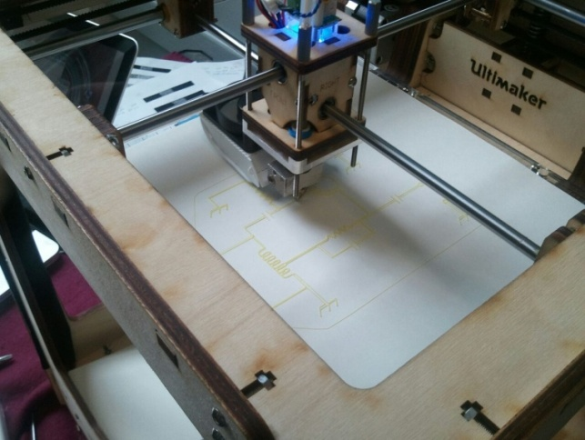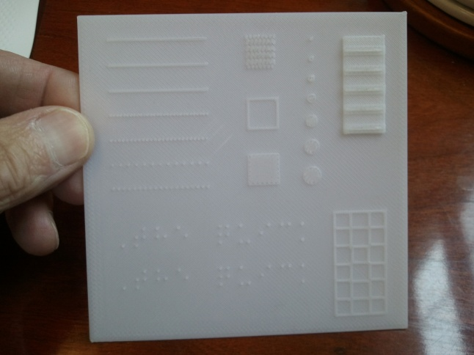
Fig. 1 Photo of the Ultimaker, a low cost kit from the Netherlands. Fig.2 NE Univ. 4x4 inch mold with solid base & graphic

To prepare a file for the 3D printer one would normally define a base layer square with a defined thickness, and then the specific image would be added on top of the base. This is shown in Figure 2 with a white plastic sample created from Northeastern University. While this is effective to create a durable, solid mold, it takes longer for the print head to build that initial layer. In order to reduce this base production time, NBP is conducting tests on various porous substrates that could be used as a base layer such as 80# weight paper, cardboards, or some plastics. Then the image build could be simply added to this substrate layer. Figure 3 below shows a test sample of a circuit diagram that was extruded onto an 80# braille paper, and Figure 4 is a thermoform reproduction. While the plastic rendering sticks fairly well to the paper, it is a little brittle and the flexibility of the paper can cause parts of the diagram to possibly break off when the paper is bent. Whatever substrate we test in the future has to be more porous, less flexible and have a good surface for the extruded plastic to adhere to better.

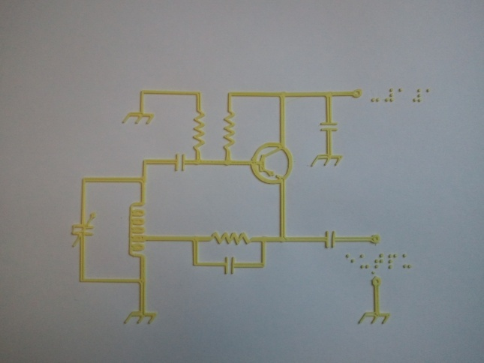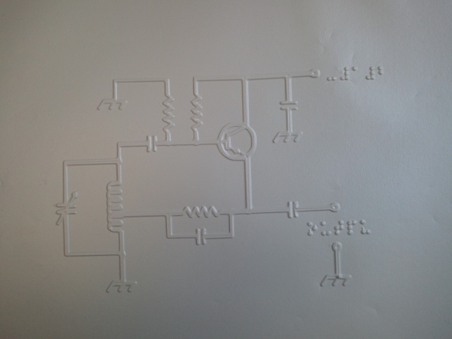
Fig.3. A 3D graphic test on paper substrate of a circuit diagram. Fig.4 Thermoform copy of a circuit diagram

Another consideration whether to build a plastic base substrate or not, is the quantity of a given graphic needed to be produced. If a TVI (Teacher of the Visually Impaired) was making this for a student in a classroom, it would be possible to consider just using the original mold as the tactile graphic, vs. thermoforming a copy. Testing needs to be done to see how the original plastic feels to determine this. If 200 copies of the same graphic were needed for a standardized test, then mass production would require thermoforming.
There are different types of plastic filaments (ABS, PLA) that have varying temperature settings, adhesion and strength. Colors seem to behave differently even for the same type of plastic. NBP will be looking at these combinations of plastic extrusions and surfaces to determine an optimum build combination.
Time studies will be conducted to determine how labor efficient this approach is compared to more traditional methods to make tactile graphics. Collage methods can render high quality graphics, however they can be laborious and they are fragile. It takes a significant amount of time to build the proper heights and to glue materials by hand on a collage graphic, especially if it is a complex diagram. Furthermore, the glue can dry up and various parts can break or fall off of the original mold. To maintain these original collage molds properly they need climate controlled rooms and to be stored vertically so that they are not crushed. Initial results look very promising. At this point we are confident that the 3D printer has the accuracy, resolution and the unique ability to create substantial height to emphasize a specific line or part of the graphic. This is a significant advantage for 3D printing compared to swell paper. One also has the advantage to create a full 3D model if needed to supplement the understanding of a graphic. Another distinct advantage with a 3D graphic is that the image can be archived electronically for a library file.

Conclusions:
As stated above, the demand and interest in 3D printers is growing rapidly with the reduction in the retail price and the open source applications for these machines. There are now even lower quality versions like the Origo which is being developed for 10 year old children to use. Schools are buying them for shop/engineering programs hobbyists are buying them for home projects, and it wouldn’t be surprising to eventually see these in Staples, where you bring in your thumb drive with a file and have them print your model for you.
NBP will continue to research and investigate the most efficient method to produce tactile graphics with this technology, and we can provide further progress reports to the DIAGRAM community in the future.
In regard to SVG, we feel confident that Inkscape is the most versatile SVG option at this time. It should be noted that the SVG Working Group (SVGWG) will be holding the 10th anniversary of their SVG Open Conference in Zurich on September 11-14, 2012. This will be the last traditional SVG conference before it transforms into a “Graphical Web” conference going forward. This will include SVG, Canvas API, WebGL, CSS, Javascript, and HTML5 video and audio.
It should be noted that the W3C SVG Interest Group is publishing a book to teach SVGs, written by Dr. David Dailey; An SVG Primer (direct link follows) http://www.w3.org/Graphics/SVG/IG/resources/svgprimer.html. Similarly, a book for designers by Tavmjong Bah called Inkscape: Guide to a Vector Drawing Program, (direct link follows) http://tavmjong.free.fr/INKSCAPE/ is another reference source on this subject.
Engaging Publishers:
Identifying a simple, affordable SVG conversion software described above is important, however it is only the beginning in an engagement process to educate and inform publishers of the advantages of including SVG as part of their production cycle. To do this properly requires a continuous, active public relations/outreach effort with updates and reports on the evolving changes in technology. However, a few points are referenced below.
- The digital transition occurring in the publishing world will result in an increase in competition for houses to produce high quality, interactive eBooks. One of the selling points to publishers is the advantage SVGs provide particularly for interactive maps, diagrams, images and video enhancements.
- SVG is an important tool for eBook reading devices to deliver resizing and reflowing content. It also includes the following advantages:
- The eBook cover of the book with SVG text over a background raster image resizes really well.
- Resizing bitmap images in SVG render much better, and as stated earlier the file size is much smaller.
- VG icons and repetitive images look great no matter how much they are scaled.
- Diagrams, equations, formulas and line images don’t degrade when resized.
- SVG Tiny (http://www.w3.org/TR/SVGTiny12/intro.html) for mobile devices works best to get quality images onto a small screen.
While the advantages to use SVGs above are valid, the disadvantages are that SVGs can be hard to create. Better supporting tools are becoming available, but most of ePUB content being created now is literary novels, and educational materials with a lot of image and illustrations haven’t happened too much yet.
In order for publishing houses or the content providers to do this an investment in SVG would be required, otherwise they will resort to simply using raster images. There are a lot of VG icons and clip-art libraries available but most of them are simple and not very sophisticated. A few examples are:
- Open Clip Art Library, http://openclipart.org/
- Raphael, http://raphaeljs.com/
- Flickr, http://www.flickr.com/groups/547272@N22/
To effectively engage publishers, DIAGRAM staff and its partners need to be advocates for all of the projects DIAGRAM is working on, and if SVG is determined to be one of those tools, the benefits of incorporating SVG can be referenced for its value to consumers. Partnering with the national organizations for the blind and visually impaired would be helpful, to have them also advocate and emphasize the importance for publishers to include SVGs as a benefit to millions of visually impaired customers. This would be particularly beneficial in the education market for e-Textbooks.
Information collateral materials on DIAGRAM’s mission and specific goals would be helpful for mass distribution and for one-on-one meetings with publishers and content providers.

As DIAGRAM staff/members do now, every opportunity to discuss the goals at meetings/convention speeches helps to get the word out. Similarly, publicity outreach to professional publication journals, and mainstream media like (WSJ, NY Times) for interviews and articles on DIAGRAM would be a great benefit.

For tactile graphics, collage refers to a combination of various materials used to create a raised presentation. Materials may be paper, string, tooling, embossing, and foil that are glued onto a base mold that is reproduced using a plastic material called braillon that is heated and under vacuum conditions with a thermoform machine to make plastic, paper-like copies.
3D printing (powder layers with pigmented colored glue: ZCorp), FDM (extruded plastic filament), Stereolithography (tracing a UV beam over a photosensitive pool of liquid) SLS (Selective Laser Sintering uses a Laser beam instead of UV)
Ultimaker, Makerbot, Printerbot, and UP! (China) are four of the new FDM kit manufacturers.

